**Day 7**

**Write a program in the following steps**

**a. Generates 10 Random 3 Digit number.**

**b. Store this random numbers into a array.**

**c. Then find the 2nd largest and the 2nd smallest element without sorting the array.**

MAXCOUNT=10

count=1

#Array name is number

while [ "$count" -le $MAXCOUNT ]; do

number[$count]=$(( ( RANDOM % 10 ) + 100 ))

let "count += 1"

done

echo "${number[*]}"

secondGreatest=$(printf '%s\n' "${number[@]}" | sort -nu | tail -2 | head -1)

echo "Second Greatest element is " $secondGreatest

secondSmallest=$(printf '%s\n' "${number[@]}" | sort -nu | head -2 | tail -1)

echo "Second Smallest element is " $secondSmallest

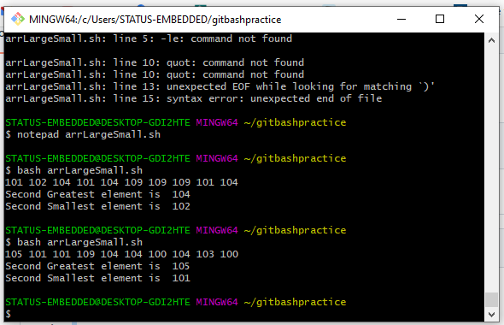

**Extend the above program to sort the array and then find the 2nd largest and the 2nd smallest element.**

MAXCOUNT=10

count=1

#Array name is number

while [ "$count" -le $MAXCOUNT ]; do

number[$count]=$(( ( RANDOM % 10 ) + 100 ))

let "count += 1"

done

echo "${number[*]}"

secondGreatest=$(printf '%s\n' "${number[@]}" | sort -nu | tail -2 | head -1)

echo "Second Greatest element is " $secondGreatest

secondSmallest=$(printf '%s\n' "${number[@]}" | sort -nu | head -2 | tail -1)

echo "Second Smallest element is " $secondSmallest

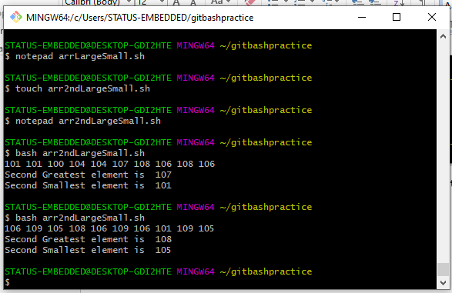

**Extend the Prime Factorization Program to store all the Prime Factors of a number n into an array and finally display the output.**

read -p "Enter a number " num

echo "All Prime Factors of $num are: "

for (( i=2; i*i<=$num; i++ ))

do

if [ $num%i == 0 ]

then

number[]=1

for (( j=2; j<=i/2; j++ ))

do

if [ i % j == 0 ]

then

number[]=0

fi

done

if [ $prime == 1 ]

then

echo ${number[@]}

fi

fi

done

**Write a Program to show Sum of three Integer adds to ZERO**

function arraySum

{

sum=0

for i in ${a[@]};

do

sum=`expr $sum + $i`

done

echo $sum

}

a=(7 2 3 9)

echo -n "Sum is = "

arraySum ${a[@]}

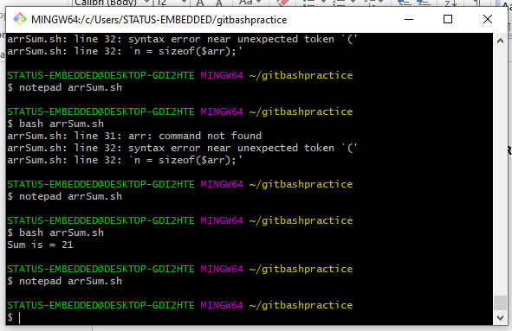

**Take a range from 0 – 100, find the digits that are repeated twice like 33, 77, etc and store them in an array**

for (( i=1;i<=9;i++ ))

do

brr=($i)

for ((j=0;j<=9;j++))

do

arr=($j)

if [ $i -eq $j ]

then

echo "$i$j"

fi

done

done

